Saturn Accessories

Paper rolls for Saturn 1000F2 Portable — Art. 20511 — Pack of 20 paper rolls — €28.90 excl. VAT


Battery — Art. 22605 — €54.95 excl. VAT
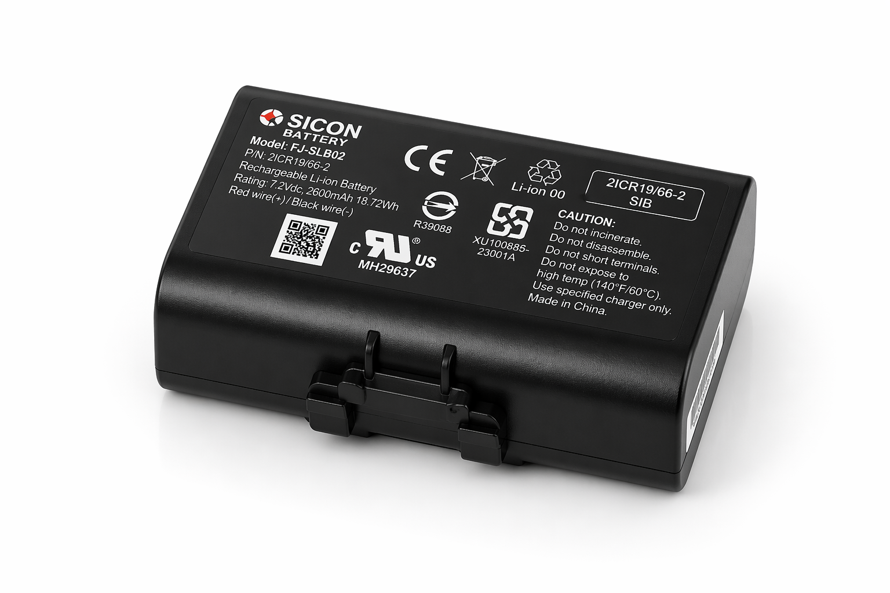

Power adapter — Art. 22610 — €12.95 excl. VAT
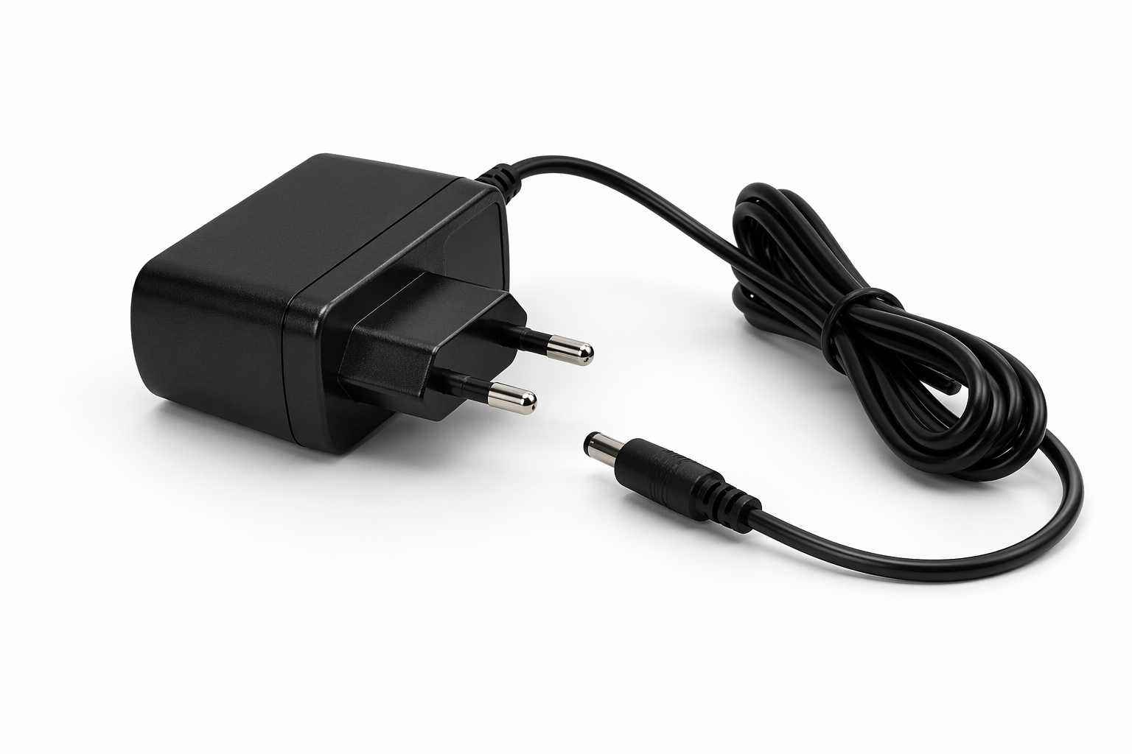

Charging station — Art. 22601 — €39.95 excl. VAT
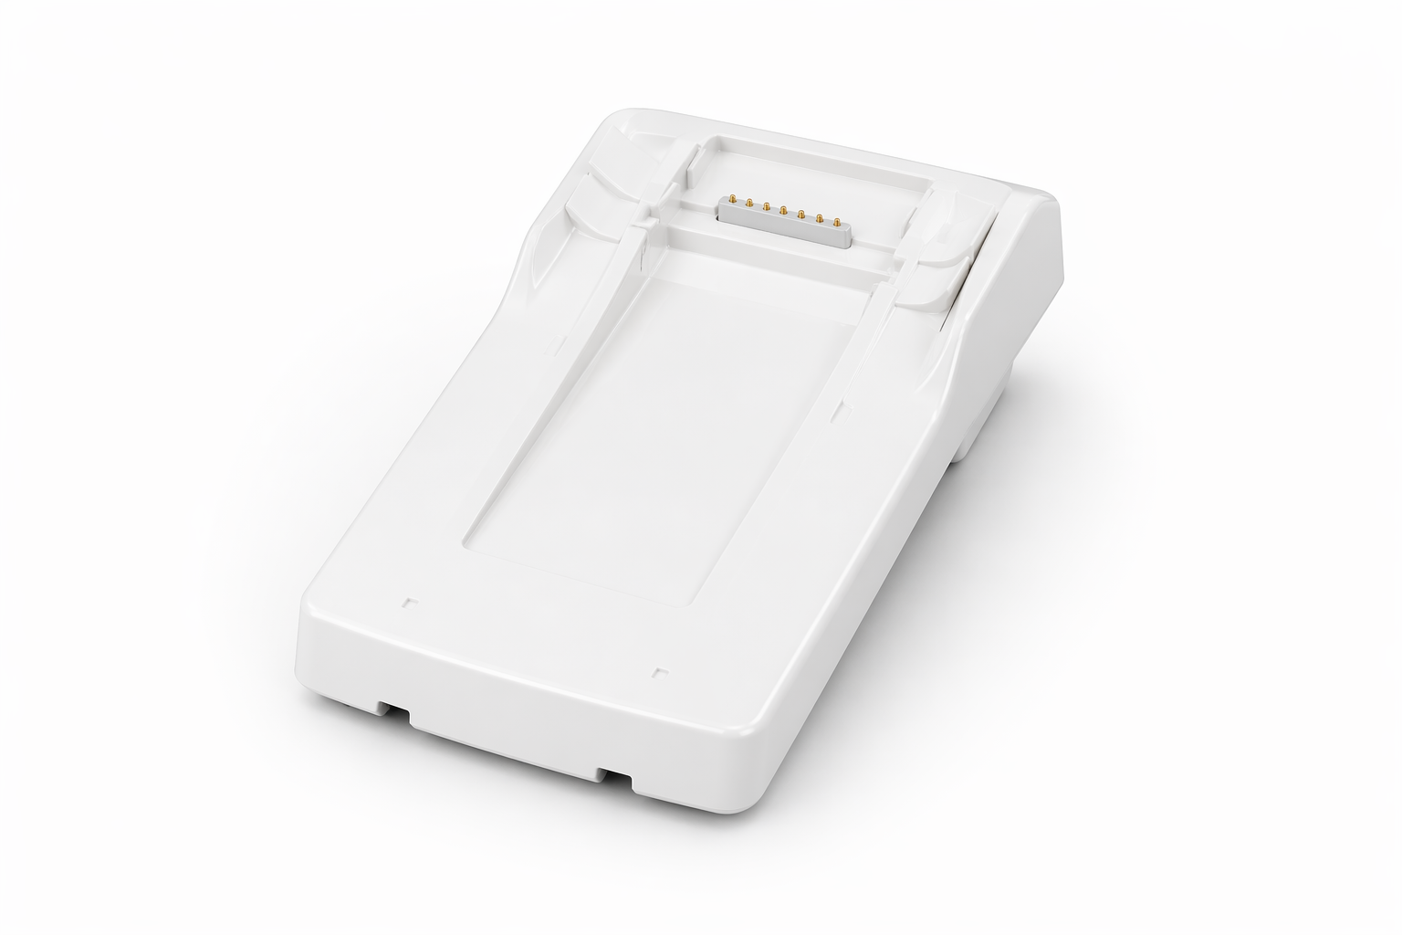

Power adapter (dock) — Art. 22606 — €34.95 excl. VAT
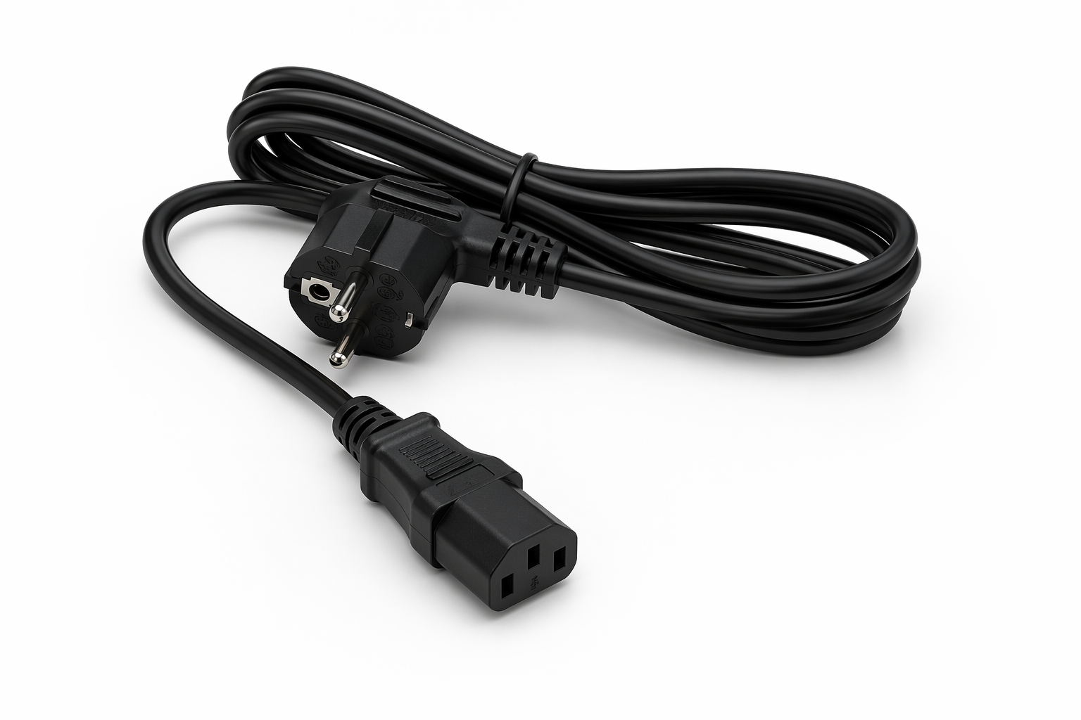

EU power cable — Art. 22603 — €9.95 excl. VAT


